**Kol Simcha Torah Gazette**

**For parsha balak 5785**

Volume 9 Issue 41 (Whole #456) 16 Tammuz 5785/ July 12, 2025

**Printed L’illuy nishmas Nechama bas R’ Noach, a”h**

For a free subscription, please forward your request to [***keren18@juno.com***](mailto:keren18@juno.com)

***Past emails can be found on the website ShabbosStories.com under Brooklyn Torah Gazette***

4**Why Israel Drives**

**the World Crazy**

**By Alister Heath**



***Alister Heath***

There’s something about Israel that makes people uncomfortable, and it’s not what they say it is.

They’ll point to politics, settlements, borders, and wars. But scratch beneath the outrage, and you’ll find something deeper.

A discomfort not with what Israel does, but with what Israel is.

A nation this small should not be this strong. Period.

Israel has no oil. No special natural resources.

A population barely the size of a mid-sized American city.

They are surrounded by enemies.

And still, they thrive like there’s no tomorrow.

In military. In medicine. In security.

In technology. In agriculture. In intelligence. In morality. In sheer, unbreakable will.

They survive wars that were supposed to wipe them out, and win.

**The world watches this and can’t make sense of it.**

So, they do what people do when they witness strength they can’t understand.

They assume it must be cheating.

It must be American aid.

It must be oppression.

It must be theft.

Because heaven forbid it’s something else.

Heaven forbid it’s real.

Heaven forbid it’s earned.

Or worse, destined.

The Jewish people were supposed to disappear a long, long time ago.

That’s how the story of exiled, enslaved, hated minorities is supposed to end.

But the Jews didn’t disappear. They actually came home, and rebuilt their land.

**That’s not normal.**

It’s not political.

**It’s biblical.**

There is no rational path from gas chambers to global influence.

And there is no historical precedent for surviving the Babylonians, the Romans, the Crusaders, the Inquisition, the pogroms, and the Holocaust.

Israel doesn’t make sense.

Unless you believe in something beyond the math.

**This is what drives the world crazy.**

Because if Israel is real, if this improbable, ancient, hated nation is somehow still chosen, protected, and thriving, then **maybe G-d isn’t a myth after all**.

Maybe He’s still in the story.

Maybe history isn’t random.

Maybe evil doesn’t get the last word.

**Maybe the Jews are not just a people, but a testimony.**

That’s what they can’t stand.

Because once you admit that Israel’s survival isn’t just impressive, but divine, everything changes.

**Your moral compass has to reset.**

Your assumptions about history, power, and justice collapse.

You realize you’re not watching the end of an empire.

**You’re witnessing the beginning of something eternal.**

So, they deny it.

They smear it.

And rage against it.

Because it’s easier to call a miracle “cheating” than to face the possibility that G-d keeps His promises.

And He’s keeping them still.

*Reprinted from the July 3, 2025 email of Rabbi Shraga Freedman. Alister Heath, a French-British journalist for the Daily Telegraph:*

**What You Need to Know About Animal Cruelty**

**By**[**Yehuda Shurpin**](https://www.chabad.org/search/keyword_cdo/kid/15169/jewish/Shurpin-Yehuda.htm)

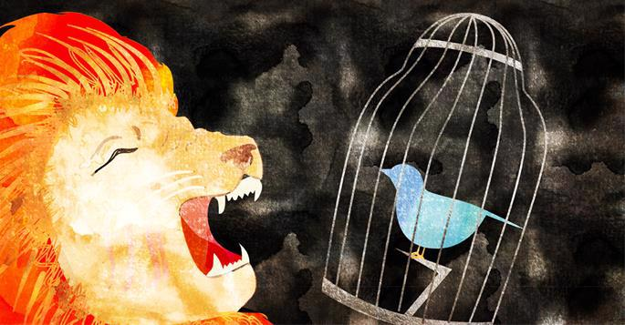

*Art by*[*Sefira Lightstone*](https://www.chabad.org/3159160)

The Torah requires us to take great care to ensure the physical and even emotional well-being of animals.[1](javascript:doFootnote('1a6940826');) This is reflected in commandments such as helping an overloaded donkey and not muzzling an ox while it works.

The [Torah](https://www.chabad.org/library/article_cdo/aid/1426382/jewish/Torah.htm) teaches that every creature has inherent value and purpose, and we are forbidden to destroy or waste resources without reason. At the same time, the Torah permits[2](javascript:doFootnote('2a6940826');) humans to benefit from animals—for work, food, or clothing—reflecting a Divinely ordained hierarchy in creation: mineral, plant, animal, and human. Lower forms are spiritually elevated when used by higher ones in service of their Creator. Based on this principle, *halachah*distinguishes between cases in which causing pain to an animal is necessary and permitted, and those in which it is unnecessary and therefore forbidden.

The prohibition against causing an animal to suffer applies only to significant pain, not minor discomfort.

For example, if an animal falls into a pit on Shabbat, one may only violate the Rabbinic *muktzeh*prohibition to rescue the animal if it cannot be cared for while in the pit. If its needs can be met there, the discomfort of being in the pit alone is not enough to override even Rabbinic restrictions of Shabbat.[3](javascript:doFootnote('3a6940826');)

**Feeding Animals Before Eating**

The verse, “And I will give grass in your field for your cattle, and then you will eat and be satisfied,”[4](javascript:doFootnote('4a6940826');) teaches that one should feed one’s animals before eating.[5](javascript:doFootnote('5a6940826');) This applies to any animal—bird, fish, or otherwise—in one’s care, but not to stray or ownerless animals.[6](javascript:doFootnote('6a6940826');) It also extends to fast days and even to interrupting a blessing (before eating) to instruct someone to feed the animals.[7](javascript:doFootnote('7a6940826');) Drinking, however, is generally permitted beforehand, as illustrated in the stories of Eliezer and Rebecca[8](javascript:doFootnote('8a6940826');) and of Moses and the Jewish people in the desert.[9](javascript:doFootnote('9a6940826');)[10](javascript:doFootnote('10a6940826');)

On Shabbat and festivals, we are permitted—and obligated—to feed animals dependent on us, but may not feed animals that aren’t reliant on our care.

**Neutering or Spaying Animals**

One is prohibited from spaying or neutering an animal. While some associate this with *tzaar baalei chayim,* technically it is a separate prohibition (at least for male animals). Thus, even if it didn’t cause the animal pain, it would still be prohibited.[11](javascript:doFootnote('11a6940826');) One is, however, permitted to purchase an animal that has already been neutered by a non-Jew.[12](javascript:doFootnote('12a6940826');)

**Hunting and Needless Killing**

Although Judaism permits killing animals when necessary—for food, clothing, medical research, or livelihood—it strictly prohibits causing unnecessary pain.[13](javascript:doFootnote('13a6940826');)

In all of Scripture, only two people are described as hunters: Nimrod and Esau—figures portrayed negatively in Jewish tradition. Nimrod is called “a mighty hunter before the L‑rd,”[14](javascript:doFootnote('14a6940826');) and Esau is described as “a man who understood hunting, a man of the field,”[15](javascript:doFootnote('15a6940826');) (in contrast to his brother Jacob, who is described as “dwelling in tents”—symbolizing study and refinement). This alone reflects the Torah’s disapproval of hunting as a pastime.[16](javascript:doFootnote('16a6940826');)

While kosher slaughter (*shechitah*) is allowed because it is done swiftly and humanely, hunting for sport often causes prolonged suffering and death, violating both the letter and the spirit of the law. Even if the kill is quick, in which case it would not be a violation of *[tzaar baalei chayim](https://www.chabad.org/library/article_cdo/aid/1440706/jewish/Is-Animal-Testing-Kosher.htm" \o "Is Animal Testing Kosher?)*, many rabbis still oppose hunting for sport because it fosters cruelty.[17](javascript:doFootnote('17a6940826');)

Judaism values conservation and the belief that every creation has a Divine purpose. Killing animals without need—not for sustenance, not for clothing, not for legitimate use—is seen as depriving them of fulfilling their G‑d-given role in creation. The Lubavitcher Rebbe also denounced the cruelty of hunting, recounting how his predecessor was rebuked as a child for simply tearing a leaf from a tree unnecessarily, highlighting that even thoughtlessly harming plant life is improper, and all the more so when it comes to animals.[18](javascript:doFootnote('18a6940826');)

**Fishing for Sport**

While fishing is often viewed as a peaceful pastime, halachically, there is a debate whether *tzaar baalei chayim* applies. Some authorities argue that the prohibition doesn't apply to fish, noting that removing scales from live fish is permitted, unlike plucking feathers from a live goose.[19](javascript:doFootnote('19a6940826');) Others disagree, pointing out that fish caught and released often suffer injuries that lead to death, making recreational catch-and-release fishing problematic.[20](javascript:doFootnote('20a6940826');) Fishing for food or therapeutic purposes is permitted, though it’s best to keep and use the fish rather than return it to the water, in deference to the opinion that *tzaar baalei chayim* does apply to fish.

**Using Animals for Medical Experiments**

As mentioned earlier, causing an animal pain is permitted when it serves a beneficial purpose, such as healing or other human needs. However, Rabbi Moshe Isserlis (the Rama), in the Code of Jewish Law, adds that even when technically allowed, one should still, as an act of piety, avoid causing unnecessary pain, since cruelty can negatively affect a person’s character traits.[21](javascript:doFootnote('21a6940826');)

Some, therefore, argue that although animal testing for medical or scientific purposes may be halachically permitted, it should be avoided to prevent fostering cruelty.[22](javascript:doFootnote('22a6940826');)

Others strongly disagree with this approach. They maintain that one may not be extra stringent when the lives of others are at stake. Prioritizing animal welfare over human life is misplaced morality.[23](javascript:doFootnote('23a6940826');) Thus, even according to Rabbi Isserlis, it is fully permitted to experiment on animals for human benefit.

While this reasoning applies to medical research, when it comes to using animals for other types of studies or testing, one must be mindful of the warning against cruelty and should consult a rabbi with any specific questions.

**Killing Insects and Small Creatures**

Jewish law permits killing insects or animals that are a nuisance, such as pests in the home or creatures that threaten health, food, or safety. This includes mosquitoes, flies, lice, mice, ants, and spiders—especially when they bite, spread disease, or infest food. The principle is that *tzaar baalei chayim* does not apply when the act serves a human need. Thus, exterminating bugs or rodents for health, cleanliness, or peace of mind is halachically permitted.[24](javascript:doFootnote('24a6940826');) Dangerous creatures that may cause injury, like snakes, must be killed to prevent future harm. Still, one should avoid causing unnecessary pain—if the same result can be achieved with less suffering (e.g., using poison or traps), it is preferred. Additionally, one should use indirect methods in order to avoid cultivating cruel character traits.[25](javascript:doFootnote('25a6940826');)

**Going Beyond the Letter of the Law**

That said, many great sages chose to avoid directly killing even nuisance insects. Both the Arizal[26](javascript:doFootnote('26a6940826');) and Rabbi Sholom Dovber of Lubavitch,[27](javascript:doFootnote('27a6940826');) for instance, would brush away mosquitoes rather than kill them, reflecting a refined spiritual awareness of the Divine purpose in all life. While this exemplary conduct is not required, it is praiseworthy for those who can adopt it. Still, if indirect killing would cause greater suffering, some authorities rule that killing directly may be preferable.

**Footnotes**

[1.](https://www.chabad.org/library/article_cdo/aid/6940826/jewish/What-You-Need-to-Know-About-Animal-Cruelty.htm" \l "footnoteRef1a6940826) While there is some debate whether the prohibition against causing pain to animals is Biblical or Rabbinic, most authorities agree it is Biblical. See *Shulchan Aruch Harav, Choshen Mishpat, hilchot ovrei derachim vtzaar baalei chayim* 1. For the most part, however, it makes no practical halachic difference—hurting animals is strictly forbidden either way. There, however, is one area where this distinction matters. The *Shulchan Aruch Harav Orach Chayim*305:29 rules that although a Jew may not milk a cow on Shabbat, it is permitted to ask a non-Jew to do so. This is because if a cow is not milked for 24 hours, it experiences significant pain. Since the *Shulchan Aruch Harav* considers preventing animal suffering a Biblical obligation, it overrides the Rabbinic prohibition against instructing a non-Jew to perform work on Shabbat (*amira le’nochri*).

[2.](https://www.chabad.org/library/article_cdo/aid/6940826/jewish/What-You-Need-to-Know-About-Animal-Cruelty.htm" \l "footnoteRef2a6940826) See for example,*Shulchan Aruch Harav, Choshen Mishpat*, *hilchot ovrei derachim vtzaar baalei chayim*4.

[3.](https://www.chabad.org/library/article_cdo/aid/6940826/jewish/What-You-Need-to-Know-About-Animal-Cruelty.htm" \l "footnoteRef3a6940826) See Nimukei Yosef on Bava Metzia 32b

[4.](https://www.chabad.org/library/article_cdo/aid/6940826/jewish/What-You-Need-to-Know-About-Animal-Cruelty.htm" \l "footnoteRef4a6940826) Berachot 40a.

[5.](https://www.chabad.org/library/article_cdo/aid/6940826/jewish/What-You-Need-to-Know-About-Animal-Cruelty.htm" \l "footnoteRef5a6940826) [Deuteronomy 11:15](https://www.chabad.org/9975#v15).

[6.](https://www.chabad.org/library/article_cdo/aid/6940826/jewish/What-You-Need-to-Know-About-Animal-Cruelty.htm" \l "footnoteRef6a6940826) *Shevut Yaakov* 3:13; *Piskei Teshuvot, Orach Chaim* 167:15.

[7.](https://www.chabad.org/library/article_cdo/aid/6940826/jewish/What-You-Need-to-Know-About-Animal-Cruelty.htm" \l "footnoteRef7a6940826) *Shulchan Aruch, Orach Chaim* 167:5; *Shulchan Aruch Harav, Orach Chaim*167:8.

[8.](https://www.chabad.org/library/article_cdo/aid/6940826/jewish/What-You-Need-to-Know-About-Animal-Cruelty.htm" \l "footnoteRef8a6940826) [Genesis 24:18](https://www.chabad.org/8219#v18)–19.

[9.](https://www.chabad.org/library/article_cdo/aid/6940826/jewish/What-You-Need-to-Know-About-Animal-Cruelty.htm" \l "footnoteRef9a6940826) [Exodus 17:3](https://www.chabad.org/9878#v3).

[10.](https://www.chabad.org/library/article_cdo/aid/6940826/jewish/What-You-Need-to-Know-About-Animal-Cruelty.htm" \l "footnoteRef10a6940826) See *Sefer Chassidim*, 531.

[11.](https://www.chabad.org/library/article_cdo/aid/6940826/jewish/What-You-Need-to-Know-About-Animal-Cruelty.htm" \l "footnoteRef11a6940826) See [Leviticus 22:24](https://www.chabad.org/9923#v24); *Shulchan Aruch, Even Haezer* 5:11.

[12.](https://www.chabad.org/library/article_cdo/aid/6940826/jewish/What-You-Need-to-Know-About-Animal-Cruelty.htm" \l "footnoteRef12a6940826) See *Shulchan Aruch, Even Haezer* 5:14.

[13.](https://www.chabad.org/library/article_cdo/aid/6940826/jewish/What-You-Need-to-Know-About-Animal-Cruelty.htm" \l "footnoteRef13a6940826) See, for example, *Shulchan Aruch Harav, Choshen Mishpat*, *hilchot ovrei derachim vtzaar baalei chayim*4*.*

[14.](https://www.chabad.org/library/article_cdo/aid/6940826/jewish/What-You-Need-to-Know-About-Animal-Cruelty.htm" \l "footnoteRef14a6940826) [Genesis 10:9](https://www.chabad.org/8174#v9).

[15.](https://www.chabad.org/library/article_cdo/aid/6940826/jewish/What-You-Need-to-Know-About-Animal-Cruelty.htm" \l "footnoteRef15a6940826) [Genesis 25:27](https://www.chabad.org/8220#v27).

[16.](https://www.chabad.org/library/article_cdo/aid/6940826/jewish/What-You-Need-to-Know-About-Animal-Cruelty.htm" \l "footnoteRef16a6940826) See, for example, *Noda B’Yehudah* *Mahadura Tinyana, Yoreh De’ah* 10.

[17.](https://www.chabad.org/library/article_cdo/aid/6940826/jewish/What-You-Need-to-Know-About-Animal-Cruelty.htm" \l "footnoteRef17a6940826) See *Noda B’Yehudah* *Mahadura Tinyana, Yoreh De’ah* 10.

[18.](https://www.chabad.org/library/article_cdo/aid/6940826/jewish/What-You-Need-to-Know-About-Animal-Cruelty.htm" \l "footnoteRef18a6940826) Talk by the Lubavitcher Rebbe, 15th of Shevat, 5732.

[19.](https://www.chabad.org/library/article_cdo/aid/6940826/jewish/What-You-Need-to-Know-About-Animal-Cruelty.htm" \l "footnoteRef19a6940826) See, for example, *Siach Yitzchak (Weiss)*, 387.

[20.](https://www.chabad.org/library/article_cdo/aid/6940826/jewish/What-You-Need-to-Know-About-Animal-Cruelty.htm" \l "footnoteRef20a6940826) *Responsum Mishnah Halachot* 6:216.

[21.](https://www.chabad.org/library/article_cdo/aid/6940826/jewish/What-You-Need-to-Know-About-Animal-Cruelty.htm" \l "footnoteRef21a6940826) *Shulchan Aruch, Even Haeze*r 5:14; See also*Shulchan Aruch Harav, Choshen Mishpat, Hil. Ovrei Derachim V’tzaar Baalei Chayim*4*.*

[22.](https://www.chabad.org/library/article_cdo/aid/6940826/jewish/What-You-Need-to-Know-About-Animal-Cruelty.htm" \l "footnoteRef22a6940826) See *Chelkat Yaakov, Choshen Mishpat* 34.

[23.](https://www.chabad.org/library/article_cdo/aid/6940826/jewish/What-You-Need-to-Know-About-Animal-Cruelty.htm" \l "footnoteRef23a6940826) See *Seridei Aish* 3:7; also cited in *Chelkat Yaakov*; ibid. 35.

[24.](https://www.chabad.org/library/article_cdo/aid/6940826/jewish/What-You-Need-to-Know-About-Animal-Cruelty.htm" \l "footnoteRef24a6940826) See *Shulchan Aruch Harav, Choshen Mishpat, Hil. Ovrei Derachim V’tzaar Baalei Chayim* 4, *Hilchot Shemirat Haguf Vehanefesh* 8.

[25.](https://www.chabad.org/library/article_cdo/aid/6940826/jewish/What-You-Need-to-Know-About-Animal-Cruelty.htm" \l "footnoteRef25a6940826) See *Igrot Moshe, Choshen Mishpat*2:47.

[26.](https://www.chabad.org/library/article_cdo/aid/6940826/jewish/What-You-Need-to-Know-About-Animal-Cruelty.htm" \l "footnoteRef26a6940826) *Shaar Hamitzvot Noach; Shaar Hagilgulim* 38.

[27.](https://www.chabad.org/library/article_cdo/aid/6940826/jewish/What-You-Need-to-Know-About-Animal-Cruelty.htm" \l "footnoteRef27a6940826) See *Reshimot*, no. 155.

*Reprinted from the current website of Chabad.Org*

**The Cell Phone Mistake**

Rav Yissocher Frand once said, “I know a businessman who is very successful and does multi-million-dollar deals. He has a policy. If you are talking to him and there is a pause in the conversation, and you check your cell phone, no matter how lucrative that deal is for him, the deal is over. Deal off.

He says, ‘If you don’t have the courtesy to respect me and give me your full attention, I’m not interested in doing business with you.’”

Rav Frand said, “I wonder if Hashem has the same policy. We Daven to Hashem. We want Parnasah, we want Gezunt, health, we want Shidduchim, we want Nachas. Hashem says, ‘If you look at your cell phone while you are Davening to Me, I’m sorry, no deal!’

Chazal tell us that people are greatly influenced by the way we act. If we act the part, and we act as though we are standing before Hashem, the Melech Malchei HaMalachim, the King of kings, HaKadosh Boruch Hu, my hunch is that it may actually improve our Kavanah when we Daven!”

*Reprinted from the Parshas Chukas 5785 email of Rabbi Yehuda Winzelberg’s Torah U’Tefilah.*

**Rav Avigdor Miller on How**

**Can You Mourn for the**

**Churban Beis Hamikdash?**

**the**



First-of-all you have to think about the Beis Hamikdash. Most people don’t even think about what the Beis Hamikdash meant for Klal Yisroel.

So, when you come to the last few words in Shemona Esrei, ̇– Please Hashem! Let it be Your will that the Beis Hamikdash should be rebuilt quickly in our days, say it with kavanah. At least these words say with feeling. So even if you were sleeping through the davening at least these last few words say with feeling. Show that you understand that it’s a loss. If you don’t even recognize the loss then there’s no use even talking. So, every day, when you finish Shemona Esrei, say these words and think about them.

Also, spend some time thinking about how great of an opportunity we had when the Beis Hamikdash existed. You would come to the Beis Hamikdash and you would learn yiras Hashem just from being there. – Come to the Mikdash in order to learn how to fear Hashem. Merely by coming there and seeing the Holy Sanctuary you’d become so inspired. You know that Yonah Ha’Navi became a navi because he was present at the simchas beis hashoeivah in the Beis Hamikdash. He was so inspired that the ruach hakodesh came upon him and he became a navi. Think about that when you say Please Hashem! Let it be Your will that the Beis Hamikdash

And therefore, you must speak to the Ribono Shel Olam. “Ribono Shel Olam, please restore the Beis Hamikdash.” I’m not even talking about Moshiach. The Beis Hamikdash even without Moshiach is such an opportunity. You can gain so much yiras Hashem from seeing the Beis Hamikdash.

Of course, it won’t come without Moshiach as well. But we want Hashem to build the Beis Hamikdash once again so that we can all come together and be zoicheh to ruach hakodesh and to see Hashem. That’s why we are looking forward to the binyan Beis Hamikdash.

Little by little, you must work on thinking these thoughts and that’s the way to mourn for the Beis Hamikdash. You’ll never mourn for the Beis Hamikdash if you don’t feel the loss – if you don’t know what you’re missing. So first you must train yourself to feel how great of an opportunity it was to have the Beis Hamikdash – and then you’ll know what it means that we don’t have it. And then you’ll be able to mourn the loss.

*Reprinted from a recent email of Toras Avigdor based on a Thursday night lecture (July 2000)*

**The Lost Jews of the Amazon: How Moroccan Refugees Built a Hidden Paradise Deep in the Rainforest.**

**By Eliyahu Freedman**



In a glass case at São Paulo's Jewish Museum sits a Torah scroll that has traveled farther than most people ever will. Written in 16th-century Spain, smuggled to Morocco during the Inquisition, and carried deep into the Brazilian Amazon by Jewish refugees, this 400-year-old parchment tells one of the most extraordinary migration stories in Jewish history—and one that remained largely hidden until now.

The scroll belongs to a community that transformed one of the world's most challenging environments into what they called "Eretz Amazon"—their promised land in the rainforest.

For over two centuries, the sound of Hebrew prayers echoed through the Amazon wilderness, mixing with the calls of toucans and the splash of pink dolphins. Jewish families from Morocco traveled deeper into the world's largest rainforest than any European settlers before them, creating a hidden civilization where matzah was made from tapioca and synagogues floated on rivers.

*Worshippers continue to pray in Sha'ar Hashamayim, the first synagogue built in Belém (Amazon) in the 1820s.*

This is the story of one of the most remarkable Jewish communities in history: the Jews of the Amazon.

**From Moroccan Mellahs to Amazonian Rivers**

In the 1800s, life in Morocco's mellahs—walled Jewish quarters—meant cramped conditions, heavy taxes, and the constant burden of second-class status. But in 1824, Brazil's new constitution offered something rare: religious tolerance. Though Catholicism remained the official faith, Jews were free to practice privately—unthinkable under Portugal's earlier colonial rule. Combined with Brazil's open ports and booming trade, the Amazon began to seem like a land of promise.

For Moroccan Jews, the Amazon was a chance to live with dignity, faith, and freedom for the first time in generations.

The first Jewish families—the Acris, Benjó, and Sabbá—arrived in Belém by 1810. As the rubber boom surged between 1850 and 1910, hundreds more followed. Nearly 900 Jewish families made Belém their home, while thousands more ventured deep into the rainforest as regatões—river traders supplying remote rubber outposts. Their boats bore names like Rei Davi (King David) and Princesa de Tânger, reminders of where they came from—and what they hoped to build.

For Moroccan Jews, the Amazon wasn't just a frontier. It was a chance to live with dignity, faith, and freedom for the first time in generations.

**A Judaism That Floated**

What made this community extraordinary wasn't just their commercial success, but how they maintained Jewish identity while becoming thoroughly Amazonian. They developed what locals called "Caboclo Judaism"—a unique blend of Sephardic tradition and rainforest adaptation that would astonish rabbis from other continents.

When matzah was unavailable for Passover, they used tapioca flour. Sabbath stews were reimagined with local fish and forest fruits. Instead of shrimp, they crafted a kosher version of tacacá—a traditional Amazonian soup—by substituting fish, preserving both flavor and faith. In remote areas where forming a minyan was impossible, Jewish life continued with quiet devotion—families prayed alone or in small groups, maintaining traditions as best they could.

The community preserved Hakitia, their distinctive dialect mixing medieval Spanish, liturgical Hebrew, and Moroccan Arabic. Families still use expressions like "Que vas hacer en Brasil, mi hijo? Non beberás caldo, comerás harina e dormirás colgado!" (What are you going to do in Brazil, my son? You will not drink chicken soup, but eat flour and sleep in a hammock!)—complaints their mothers made about leaving Morocco that became cherished community folklore.

On major holidays, some traveled hundreds of miles by boat to reach synagogues in Belém or Manaus—arduous journeys that could take weeks along winding rivers. The stories they left behind border on the miraculous. In Cametá, a violent storm once washed away the local synagogue, but the community's Torah scroll was found unharmed, floating downriver. It was rescued by a local ribeirinho, whose family, according to legend, prospered from that day forward.

**The Rabbi in the Rainforest**

In 1908, Rabbi Shalom Emanuel Muyal was sent from Morocco to the Amazon to help scattered Jewish communities maintain religious life. For two years, he traveled tirelessly between settlements, offering guidance in Jewish law, training ritual leaders, and rekindling a sense of connection for Jews who had gone years without a rabbi.

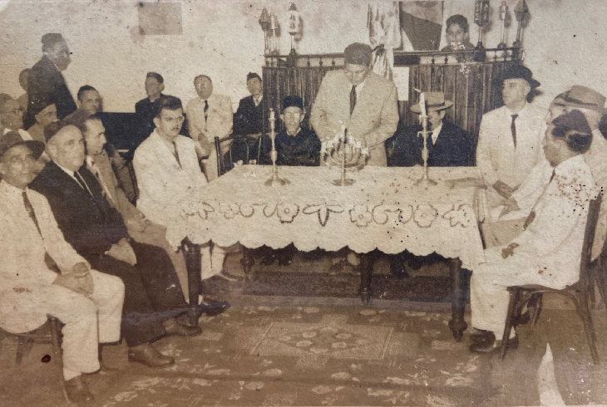*Jacob Azulay, a Moroccan immigrant from Casablanca and longtime spiritual leader in Manaus, lights the Hanukkah menorah with his brothers Moisés and Elias.*

When he died of yellow fever in 1910, stories spread of people visiting his grave and experiencing healing. Locals began to view him as a spiritual figure of blessing, and his resting place quietly became a site of popular reverence—one of the more unusual intersections of Jewish presence and Amazonian faith.

**The Promised Rainforest**

When the rubber boom ended around 1910, many families migrated to Brazil's southeast, but the Amazon had changed them permanently. Today, roughly 850 Jews remain in Manaus, with smaller communities scattered throughout the Amazon basin. More than 20 Jewish cemeteries have been documented deep in the rainforest—evidence of structured communities that once thrived along the Amazon's major tributaries.

The Torah scroll at São Paulo's Jewish Museum represents more than historical curiosity; it embodies a living bridge between persecution and sanctuary, between ancient tradition and radical adaptation. It reminds us that Jewish history isn't just about survival in familiar places, but about the courage to recreate our traditions in the most unexpected corners of the world.

**An Enduring Legacy**

In an age of climate change and cultural displacement, the Amazon Jews offer profound lessons about adaptation and resilience. From rubber traders to modern entrepreneurs, from floating synagogues to urban communities, they have reinvented themselves countless times while never losing their core identity.

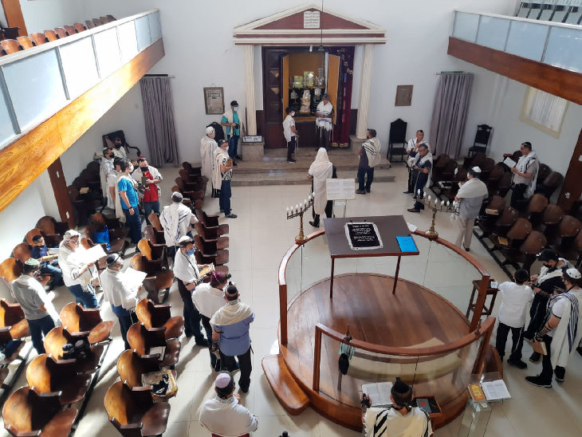*The Eshel Abraham Synagogue in Belem, a historic synagogue built for the Sephardic Jewish community who immigrated to Brazil in the 1820s.*

Today's generation faces new challenges—climate change, urbanization, globalization—but they approach them with the same spirit their ancestors brought to the rainforest: not as obstacles to overcome, but as opportunities to discover new ways of being Jewish in an ever-changing world.

The Amazon Jews demonstrate that authentic Jewish communities aren't always found in the most traditional places. Sometimes they emerge where Hebrew prayers mix with the sounds of the rainforest and where ancient wisdom responds to new realities.

*Reprinted from the current website of aish.com Photo credit (used with permission – Portal Amazonia Judaica.)*